SQL Joins
Java + DSAPwskills

Note : Create the following dummy tables in MySQL Workbench using CREATE FUNCTION-
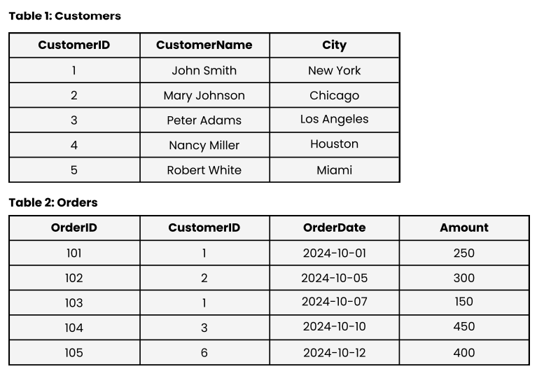
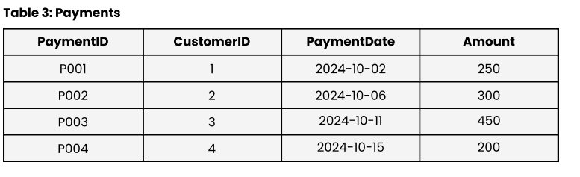
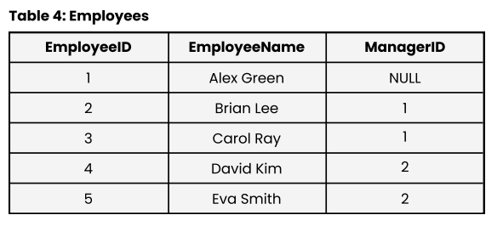
TABLE CREATION :

create table Customers(CustomerID int, CustomerName varchar(50), City varchar(50));
create table Orders(OrderID int, CustomerID int, OrderDate date, Amount int);
create table Payments(PaymentID varchar(50),CustomerID int,PaymentDate date, Amount int);
create table Employees(EmployeeID varchar(50),EmployeeName varchar(50),ManagerID int);

Select * from Customers;
Select * from Orders;
select * from Payments;
select * from Employees;

drop table Orders;

Alter table Employees RENAME TO Employees1;
insert into Customers (CustomerID, CustomerName, City)values(1,'John Smith','New York'), (2,'Mary Johnson','Chicago'),(3,'Peter Adams','Los Angeles'),
(4,'Nancy Miller','Houston'),
(5,'Robert White','Miami');

insert INTO Orders (OrderID, CustomerID, OrderDate, Amount) value(101,1,'2024-10-01',250),(102,2,'2024-10-05',300),(103,1,'2024-10-07',150),(104,3,'2024-10-10',400),
(105,6,'2024-10-12',450);

INSERT INTO Payments (PaymentID, CustomerID, PaymentDate, Amount)
VALUES ('P001', 1, '2024-10-02', 250), ('P002', 2, '2024-10-06', 300), ('P003', 3, '2024-10-11', 450),
('P004', 4, '2024-10-15', 200);

INSERT INTO Employees (EmployeeID, EmployeeName, ManagerID) VALUES (1, 'Alex Green', NULL),
(2, 'Brian Lee', 1), (3, 'Carol Ray', 1),(4, 'David Kim', 2),(5, 'Eva Smith', 2);

Question 1. Retrieve all customers who have placed at least one order.
Solution :-
select Distinct cust.CustomerName from Customers cust inner join orders ord where cust.CustomerID = ord.CustomerID;

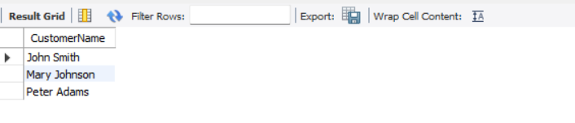

Question 2. Retrieve all customers and their orders, including customers who have not placed any orders.
Solution :-
SELECT c.CustomerID, c.CustomerName, c.City, o.OrderID, o.OrderDate, o.Amount FROM Customers c
LEFT JOIN Orders o ON c.CustomerID = o.CustomerID;
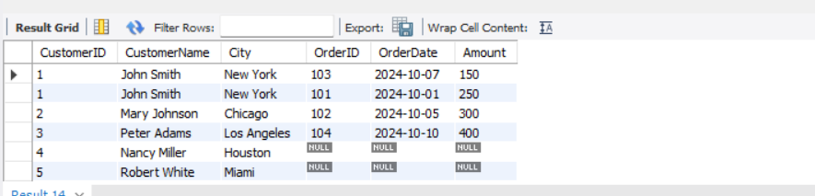

Question 3. Retrieve all orders and their corresponding customers, including orders placed by unknown customers.
Solution :-
select o.OrderID, o.OrderDate, o.CustomerID, o.Amount, c.CustomerName, c.City FROM Customers c
RIGHT JOIN Orders o ON c.CustomerID = o.CustomerID;
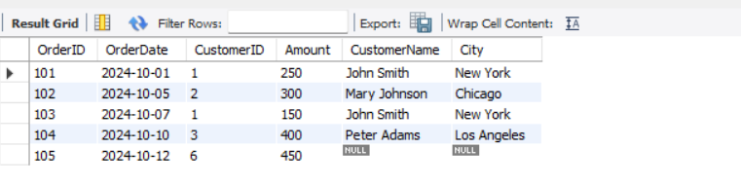

Question 4. Display all customers and orders, whether matched or not.
Solution :-
SELECT c.CustomerID, c.CustomerName, c.City, o.OrderID, o.OrderDate, o.Amount FROM Customers c
LEFT JOIN Orders o ON c.CustomerID = o.CustomerID UNION SELECT c.CustomerID, c.CustomerName, c.City,
o.OrderID, o.OrderDate, o.Amount FROM Customers c RIGHT JOIN Orders o ON c.CustomerID = o.CustomerID;
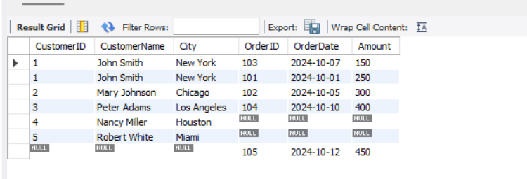

Question 5. Find customers who have not placed any orders.
Solution :-
SELECT c.CustomerID, c.CustomerName, c.City from Customers c
LEFT JOIN Orders o ON c.CustomerID = o.CustomerID where o.CustomerID is null;
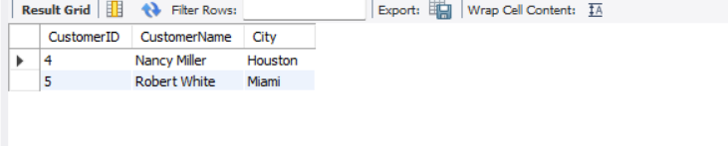

Question 6. Retrieve customers who made payments but did not place any orders.
Solution :-
select p.CustomerID, c.CustomerName, c.City, p.PaymentID, p.PaymentDate, p.Amount from payments p left join
Orders o ON p.CustomerID = o.CustomerID join Customers c ON p.CustomerID = c.CustomerID where o.CustomerID is NULL;
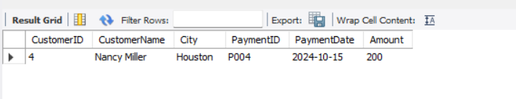
Question 7. Generate a list of all possible combinations between Customers and Orders.
Solution :-
SELECT c.CustomerID, c.CustomerName, o.OrderID, o.OrderDate, o.Amount FROM Customers c JOIN Orders o;
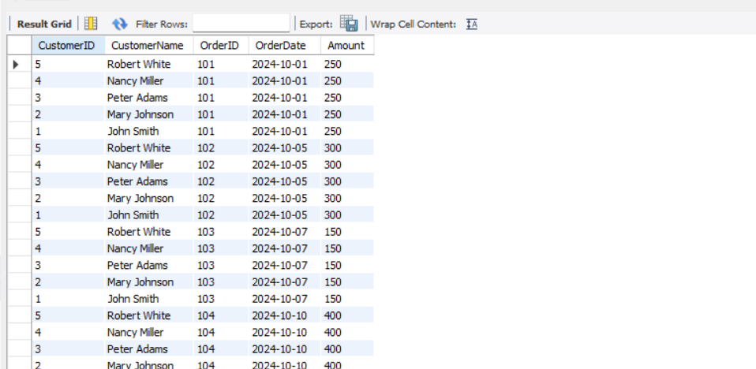


Question 8. Show all customers along with order and payment amounts in one table.
Solution :-
SELECT c.CustomerID,c.CustomerName,c.City,o.OrderID,o.OrderDate AS OrderDate ,p.Amount AS PaymentAmount FROM Customers c LEFT JOIN Orders o ON c.CustomerID = o.CustomerID
LEFT JOIN Payments p ON c.CustomerID = p.CustomerID;
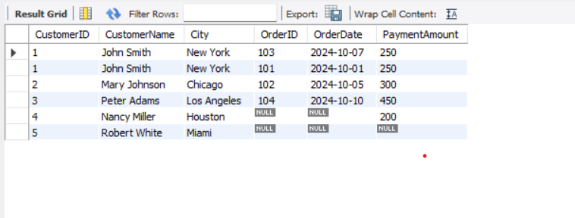Question 9. Retrieve all customers who have both placed orders and made payments.
Solution :-
SELECT distinct c.CustomerID,c.CustomerName,c.City from Customers c inner join orders o on c.customerID = o.customerID
inner join payments p on c.customerID = p.customerID;
